**[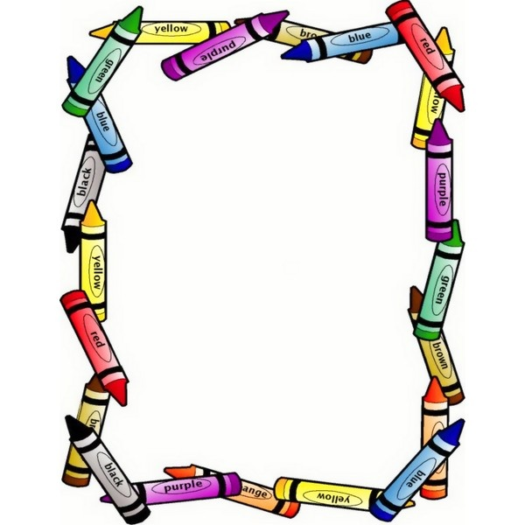](http://www.google.com/url?sa=i&rct=j&q=&esrc=s&source=images&cd=&cad=rja&uact=8&ved=0CAcQjRxqFQoTCJ_4gLHM8MYCFUSXgAodw2MLJg&url=http://www.clipartpanda.com/categories/free-printable-preschool-borders&ei=1YWwVd-5C8SuggTDx62wAg&bvm=bv.98476267,d.eXY&psig=AFQjCNEvw7AuOseDYhaj8h1q4PCWx_0lsA&ust=1437718355709423)**

**Pre-K ASD Suggested Supply List**

**2025-2026**

**Mrs. Gibson**

Your child will need:

* 1.5 inch binder
* 1 **regular** sized backpack (no rolling backpacks)
* 1 blanket
* 1 set of clothes to stay in the classroom (top/bottom/underwear/socks) labeled in a large zip-lock bag
* If your child is not potty trained, please send in

**enough pull-ups and wipes for the entire week**, weekly if not more.

* 1 water bottle to send back and forth to school, **please label** with your childs name

PLEASE label all your childs things first and last name

with permanent marker. Thanks! ☺

**Extra Supplies**

Jumbo Crayons

Markers Band-aides

Elmers Glue Sticks

Adhesive Velcro

Expo Markers Bubbles

Assorted construction Paper

**Classroom Shared Supplies**

Box of Tissue Lysol wipes

Hand soap Baby wipes

Hand sanitizer Disinfected Spray

Large Ziplock bags

**Shared Snacks**

Gold fish Veggie Straws Cheeseballs

Animals crackers Pretzels Cheezits